Color your country.

What continent is your country in?
Choose : ASIA - AFRICA – AMERICA – EUROPE.

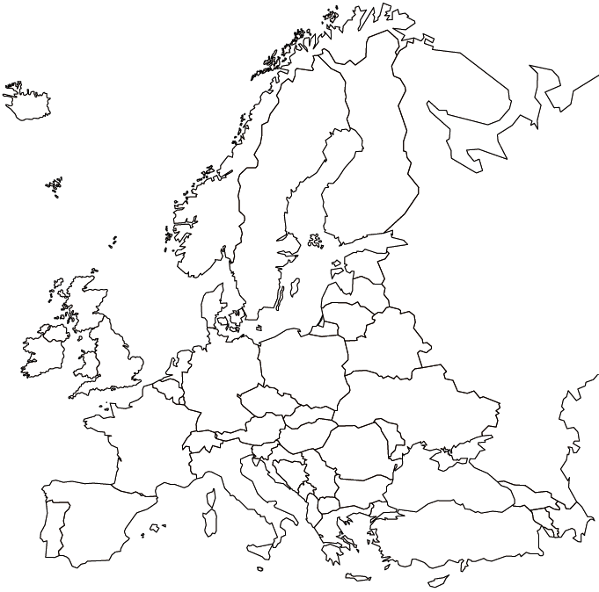

CHOOSE ONE
I LIVE IN……..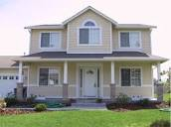 a HOUSE
I LIVE IN ……..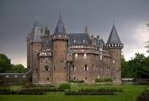 a CASTLE
I LIVE IN……..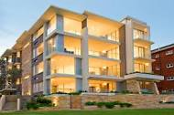 an APARTMENT
I LIVE IN……..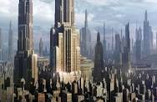 a SKYSCRAPER

Look and read. Choose the correct words and write them on the lines.
a supermarket the post office a train station a fountain a hill the playground a square hometown a hotel a river a castle school

You go there every day and meet your teacher and you mates ……………………………… .
You meet your friends and play in this open space ……………………………………… .
Your friends, your family and you live in it …………………………………….. .
In the centre of your town, you can find this open space where people meet ………………………………...... .
This ancient building was the house of a king …………………………………. .
It is not a mountain and it is not a flat ground ……………………………… .
Water flows in it, it can be in a square ……………………………. .
This flowing water connects different countries …………………………….. .
Tourists often go to sleep there …………………………. .
Mums go to buy food here ……………………………………. .
You can send letters and parcels from there ………………………................ .

MATCH THE FLAG,THE NAME AND THE SYMBOL WITH COLOURED ARROWS
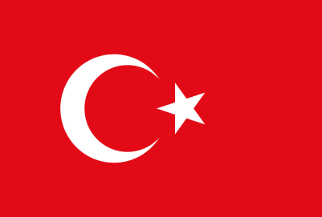 | ITALY | 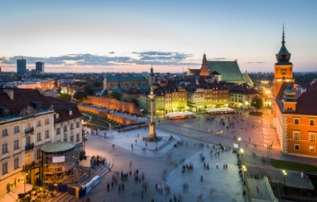
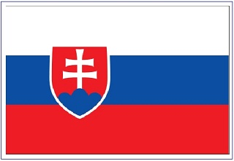 | TURKEY | 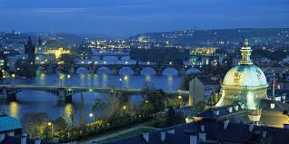
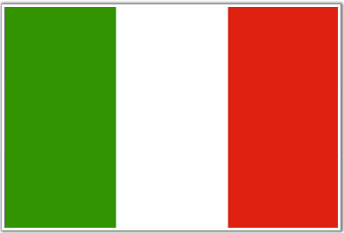 | POLAND | 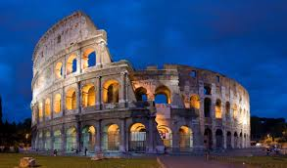
 | CZECH REPUBLIC | 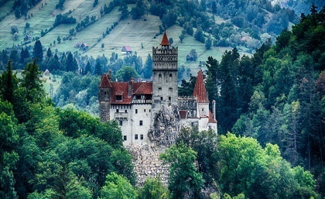
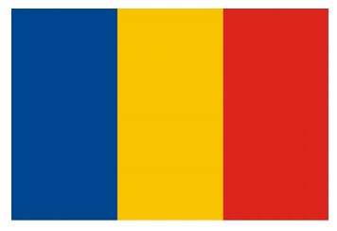 | SLOVAKIA | 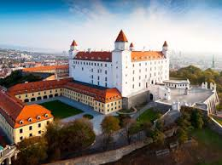
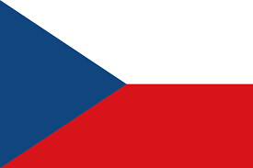 | ROMANIA | 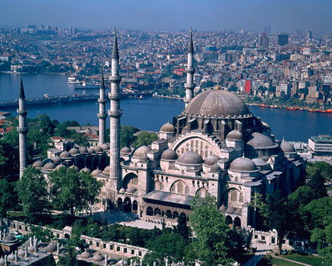

WRITE THE NUMBER NEXT TO THE RIGHT PICTURE
1. COUNTRY 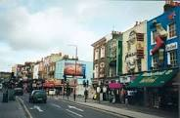
2. VILLAGE
3. TOWN
4. CITY 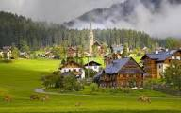
5. STATE 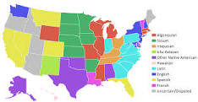

A) TEACHER – B) PRINCIPAL – C) CHILD
Write the word in the picture

-----------

------------

------------

